
SCHOOL OF COMPUTING AND ENGINEERING SCIENCES (SCES)
BACHELOR OF SCIENCE IN ELECTRICAL AND ELECTRONICS ENGINEERING (BSEEE)
PHYSICS EXPERIMENT ON COPLANAR FORCES AND MOTION
By
Mwongela Edward Aribu 142092
Collaborators
Teddy Mbugua - 142776
Mark Mbiriri - 143389
Arnold Injeni - 146279

Abstract
This is a report that contains the data obtained in a laboratory experiment conducted in the Strathmore engineering laboratories by the group members listed above. It was conducted to investigate coplanar forces, moments of forces, kinetic friction, and the facts or theories behind or related to them as well as experiments on motion.
Table of Contents
Abstract 2
Table of figures 6
INTRODUCTION 8
moment 8
friction 8
Coplanar forces 8
LITERATURE REVIEW 9
Moment of a force 9
Friction 9
Composition of concurrent forces 9
The Elements of Coplanar Force Resolution 10
Hooke’s law 11
Coefficient of kinetic friction 11
PART 1 12
EXPERIMENT 1 12
METHODOLOGY 12
Materials required 12
Procedure 12
RESULTS AND FINDINGS 13
EXPERIMENT 2 17
METHODOLOGY 17
Material required 17
Procedure 17
RESULTS AND FINDINGS 17
Conclusion 18
EXPERIMENT 3 19
METHODOLOGY 19
Materials required 19
Procedure 19
RESULTS AND FINDINGS 19
Conclusions 21
EXPERIMENT 4 22
METHODOLOGY 22
Materials required 22
Procedure 22
RESULTS AND FINDINGS 22
Conclusions 24
EXPERIMENT 5 25
METHODOLOGY 25
Materials required 25
Procedure 25
RESULTS AND FINDINGS 25
EXPERIMENT 8 32
METHODOLOGY 32
Materials required 32
Procedure 32
RESULTS AND FINDINGS 32
Conclusions 32
EXPERIMENT 12 33
METHODOLOGY 33
Materials required 33
Procedure 33
RESULTS AND FINDINGS 33
EXPERIMENT 13 35
METHODOLOGY 35
Materials required 35
Procedure 35
RESULTS AND FINDINGS 35
Measurement of the coefficient of kinetic friction 41
METHODOLOGY 41
RESULTS AND FINDINGS 41
PART 2 44
Experiment 1 44
METHODOLOGY 44
RESULTS AND FINDINGS 44
Experiment 2 45
METHODOLOGY 45
RESULTS AND FINDINGS 46
Measurement of the elastic constant of a spring 47
Objective 47
METHODOLOGY 47
Required tools and materials 47
Phases of the experiment 47
RESULTS AND FINDINGS 48
Experiment 3 49
METHODOLOGY 49
Procedure 49
RESULTS AND FINDINGS 49
Experiment 4 51
METHODOLOGY 51
procedure 51
RESULTS AND FINDINGS 52
REFERENCES 54

Table of figures
Figure 1 13
Figure 2 14
Figure 3 15
Figure 4 15
Figure 5 16
Figure 6 17
Figure 7 18
Figure 8 20
Figure 9 20
Figure 10 21
Figure 11 22
Figure 12 23
Figure 13 23
Figure 14 24
Figure 15 26
Figure 16 27
Figure 17 28
Figure 18 29
Figure 19 30
Figure 20 30
Figure 21 31
Figure 22 32
Figure 23 33
Figure 24 34
Figure 25 34
Figure 26 36
Figure 27 37
Figure 28 38
Figure 29 38
Figure 30 39
Figure 31 39
Figure 32 40
Figure 33 41
Figure 34 42
Figure 35 42
Figure 36 43
Figure 37 44
Figure 38 46
Figure 39 46
Figure 40 48
Figure 41 48
Figure 42 48
Figure 43 49
Figure 44 49
Figure 45 52
Figure 46 53
Figure 47 53

INTRODUCTION

moment
The moment of a force - is a measure of its tendency to cause a body to rotate about a specific point or axis. This is different from the tendency for a body to move, or translate, in the direction of the force. For a moment to develop, the force must act upon the body in such a manner that the body would begin to twist. This occurs every time a force is applied so that it does not pass through the centroid of the body. A moment is due to a force not having an equal and opposite force directly along its line of action.
(What Is a Moment?, n.d.)

Moment = Force x Distance or M = (F)(d)

friction
Friction is defined as the resistance offered by the surfaces that are in contact when they move past each other. There are four types of friction, and they are classified as follows:
- Static friction
- Sliding friction
- Rolling friction
- Fluid friction

Coplanar forces
Coplanar forces are forces on a single plane. This means that all points of application are inside that plane and that all forces are running parallel to that plane. Coplanar forces may be concurrent, non-concurrent, parallel, or non-parallel.

LITERATURE REVIEW

Moment of a force
In physics and mechanics, torque is the rotational equivalent of linear force. It is also referred to as the moment, moment of force, rotational force or turning effect, depending on the field of study.
The moment of a force or torque is defined as the turning effect of the force about a pivot and is the product of the force (F) and the perpendicular distance (d) from the line of action of the force to the pivot.
SI unit of moment of a force is Newton-meter (Nm). It is a vector quantity.
Its direction is given by the right-hand grip rule perpendicular to the plane of the force and pivot point which is parallel to the axis of rotation.

Friction
Friction is caused due to the irregularities on the two surfaces in contact. So, when one object moves over the other, these irregularities on the surface get entangled, giving rise to friction. The more the roughness, the more irregularities and more significant will be the friction.(Friction - Definition, Types of Friction, Applications & Videos, n.d.)
Friction is a force that is dependent on external factors. Following are the two factors on which friction depends:
1. On the nature of the two surfaces that are in contact
Friction is dependent on the smoothness or roughness of the two surfaces that are in contact with each other. When the surface is smooth, the friction between the two reduces as there is not much interlocking of irregularities. While the surface is rough, friction increases.
2. On the force that is acting on these surfaces
Friction increases when the force is applied along with the irregularities.

Composition of concurrent forces
Concurrent forces refer to those forces which intersect through a common point. When it comes to concurrent forces, we can add them together as vectors and this gives the net resultant.
There are two major types of equilibrium of concurrent forces. These include Static equilibrium and dynamic equilibrium. In static equilibrium, the state of the body is such that all the resultant forces add up to zero. The acceleration and velocity are both zero.
In dynamic equilibrium, the net result is zero, however, velocity is not. For example, a block resting on the floor can be said to be in static equilibrium. A block attached to a string in Simple Harmonic motion can be an example of dynamic equilibrium.

This is the simple way to define the Types of equilibrium of concurrent forces.

The Elements of Coplanar Force Resolution

There are many ways in which forces can be manipulated. It is often easier to work with a large, complicated system of forces by reducing it to an ever-decreasing number of smaller problems. This is called the "resolution" of forces or force systems. This is one way to simplify what may otherwise seem to be an impossible system of forces acting on a body. Certain systems of forces are easier to resolve than others. Coplanar force systems have all the forces acting in in one plane. They may be concurrent, parallel, non-concurrent or non-parallel. All these systems can be resolved by using graphic statics or algebra.
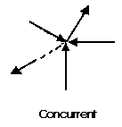

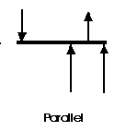
A concurrent coplanar force system is a system of two or more forces whose lines of action ALL intersect at a common point. However, all the individual vectors might not actually be in contact with the common point. These are the simplest force systems to resolve with any one of many graphical or algebraic options.

A parallel coplanar force system consists of two or more forces whose lines of action are ALL parallel. This is commonly the situation when simple beams are analysed under gravity loads. These can be solved graphically but are combined most easily using algebraic methods.
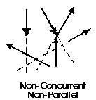
The last illustration is of a non-concurrent and non-parallel system. This consists of several vectors that do not meet at a single point and none of them are parallel. These systems are essentially a jumble of forces and take considerable care to resolve.(Coplanar Force Resolution, n.d.)

Hooke’s law
Stress and strain take different forms in different situations. Generally, for small deformations, the stress and strain are proportional to each other, and this is known as Hooke’s Law.
Hooke’s law states that the strain of the material is proportional to the applied stress within the elastic limit of that material.
When the elastic materials are stretched, the atoms and molecules deform until stress is applied, and when the stress is removed, they return to their initial state.
Mathematically, Hooke’s law is expressed as:
F = ke
In the equation is the force, x is the extension length, k is the constant of proportionality known as spring constant in N/m.

Coefficient of kinetic friction
Different types of coefficients
The different types of friction are: Static, kinetic, deformation, molecular and rolling. Each has its own coefficient of friction.
Static coefficient: is the force that holds back a stationary object up to the point that it just starts moving. Thus, the static coefficient of friction concerns the force restricting the movement of an object that is stationary on a relatively smooth, hard surface.
Kinetic coefficient: Once you overcome static friction, kinetic friction is the force holding back regular motion. This, kinetic fiction coefficient of friction concerns the force restricting the movement of an object that is sliding on a relatively smooth, hard surface.
Deformation coefficient: The deformation coefficient of friction concerns the force restricting the movement of an object that is sliding or rolling and one or both surfaces are relatively soft and deformed by the forces.
Molecular coefficient of friction: Concerns the force restricting the movement of an object that is sliding on an extremely smooth surface or where a fluid is involved.
The rolling coefficient of friction: Combines static, deformation and molecular coefficients of friction. This coefficient of friction can be made quite low(Determining the Coefficient of Friction - Succeed in Physical Science, n.d.)

PART 1

EXPERIMENT 1

METHODOLOGY

Materials required
- 1 support for dynamometer
- 2 fixed pulleys
- 1 dynamometer 250gr (2.5N)
- 1 goniometer with magnetic support
- 2 series of 10gr weights with pan
- 1 cord

Procedure
- Mount the dynamometer
- Mount the two pans loaded with weights chosen at will. The intensity of F1 and F2 is represented by the sum of the weights and of the respective pan. Pass the cord through the ring of the dynamometer and the groove of the pulleys.
- Make sure that the system is in equilibrium
- Fix the goniometer so that its centre coincides with the ring of the dynamometer.
- Measure the angle between the two forces. Align the zero of the goniometers with one of the two branches of the cord.
- Take note of the intensity of the resultant(R) on the dynamometer.
- Take note of the angle between F1 and R
- Repeat the experience, changing the values of F1, F2 and the angle
- Compare the force value on the dynamometer with that found graphically and analytically.
- By graphics, after having taken note of the values for the forces and of the angles, the relative vector diagram is constructed in scale of the graph paper. The graphical value of R, within the limit of experimental errors, must coincide with the value read on the dynamometer.

RESULTS AND FINDINGS
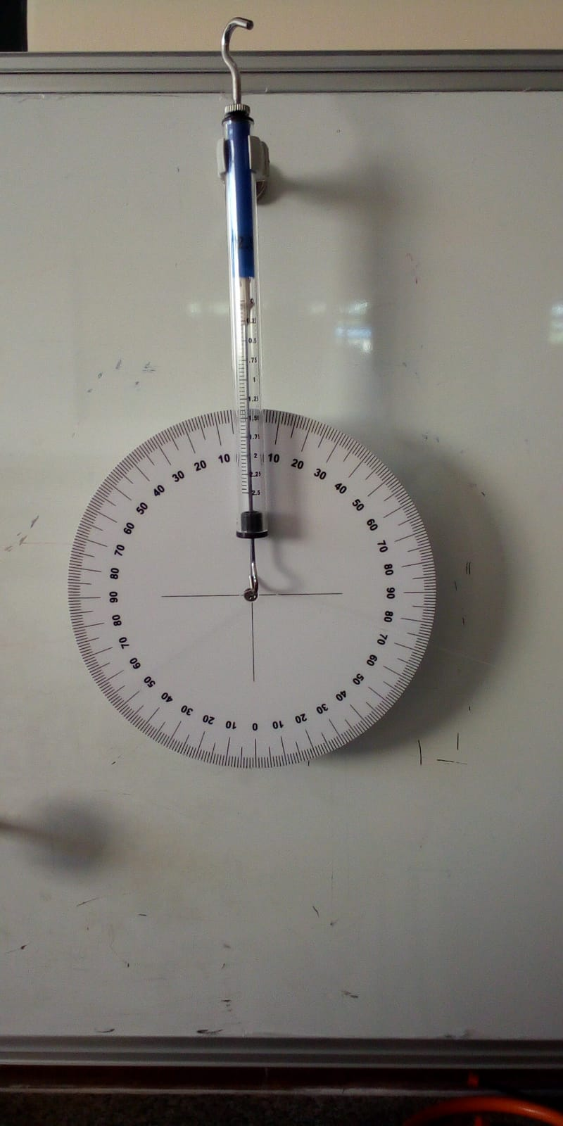
Figure 1
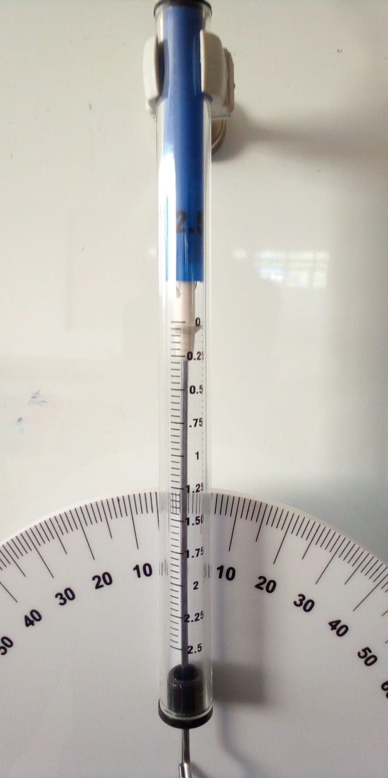
Figure 2
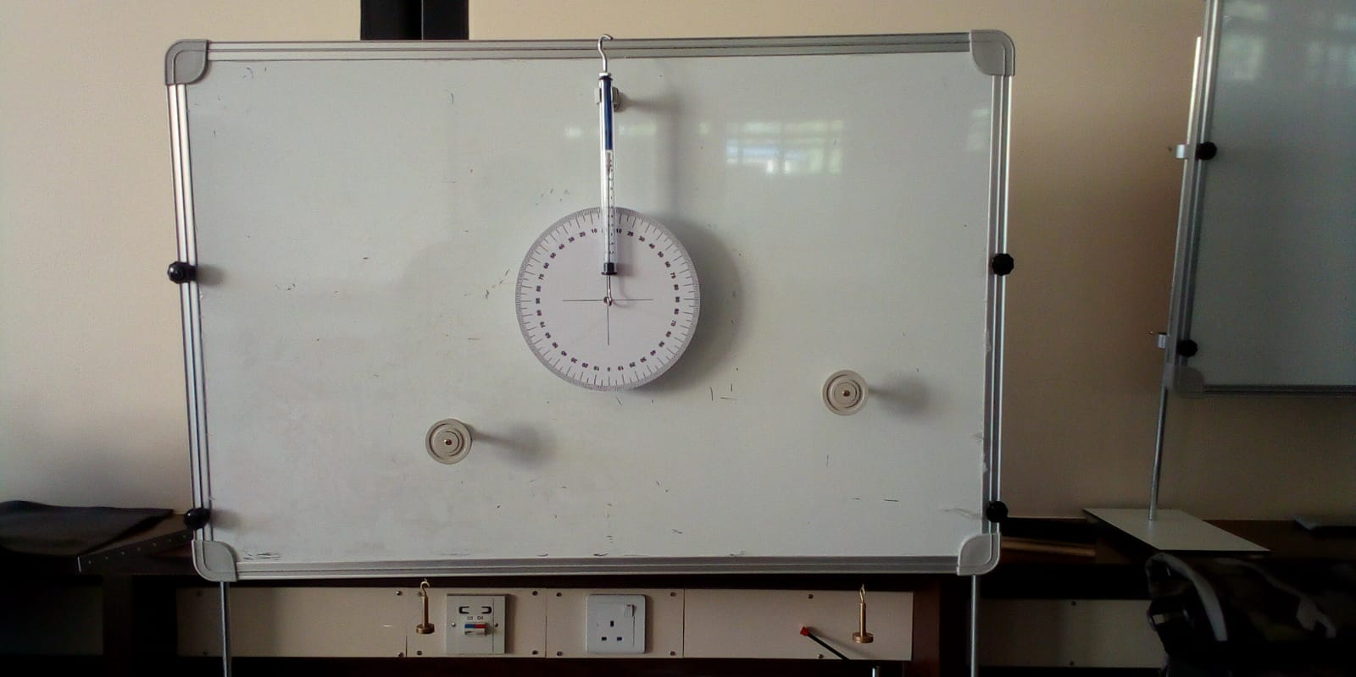
Figure 3

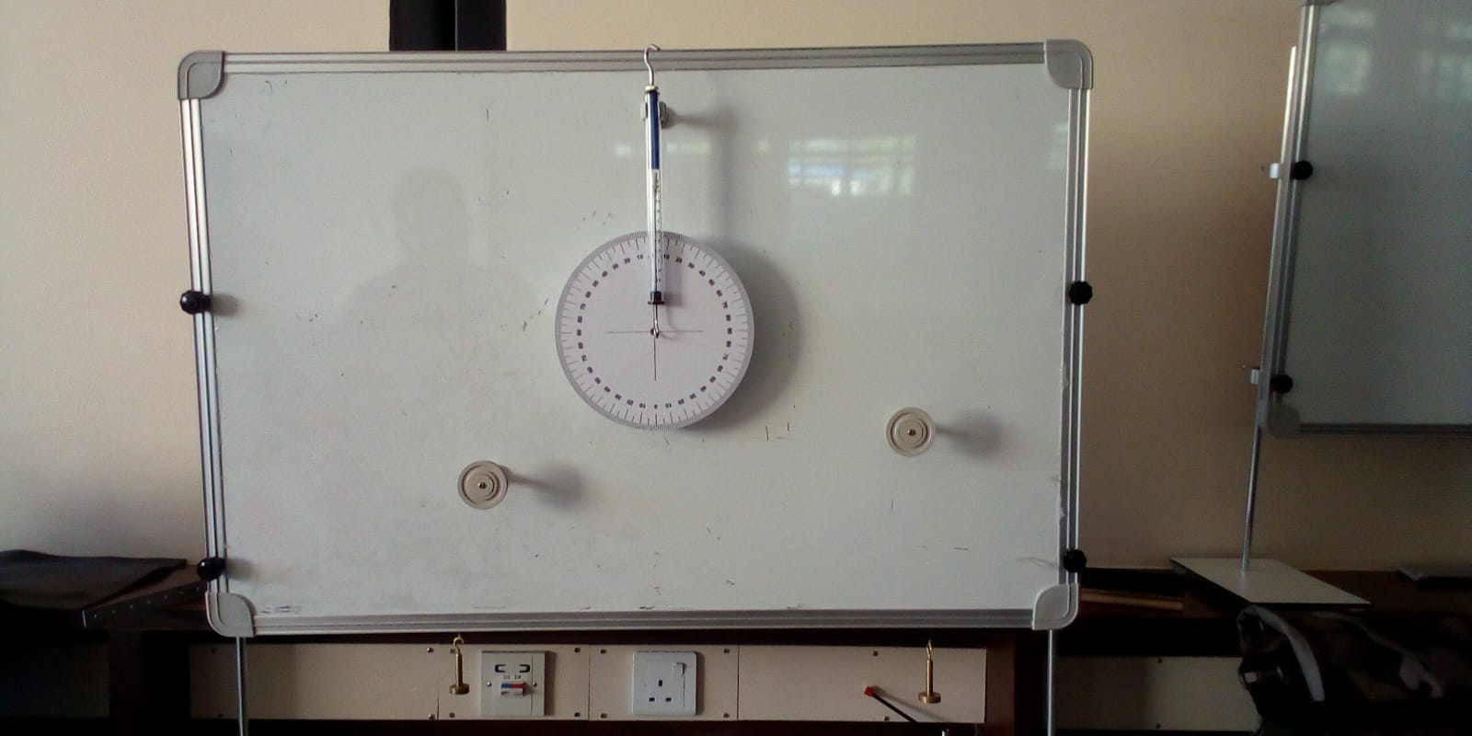
Figure 4

F1 | F2 | total | R | Angle(x⁰)
10 | 10 | 20 | 0.05 | 140
20 | 20 | 40 | 0.10 | 126
30 | 30 | 60 | 0.20 | 119
40 | 40 | 80 | 0.30 | 110
50 | 50 | 100 | 0.40 | 106
Figure 5

EXPERIMENT 2

METHODOLOGY

Material required
- 1 support for dynamometer
- 1 dynamometer 250gr (2.5N)
- 1 rod for levers
- 1 S-shaped hook
- 2 series of 10gr weights with pan
- 1 cord

Procedure
- Fix the dynamometer to the magnetic whiteboard with specific support
- Suspend the rod for levers on the dynamometer using the S-shaped hook and inserting it in the rod’s centre of mass
- Take note of the weights of the rod indicated on the dynamometer
- Apply the pans with the relative weight in the holes of the rod, on the opposite side with respect to the centre of the mass. Change the amount of weight on the pans and the distances from the centre of mass to balance the system
- When the system is in equilibrium, read the value of the resultant on the dynamometer, considering the initial tare represented by the weight of the rod.
- Repeat the experience changing the values of F1, F2, a and b.

RESULTS AND FINDINGS

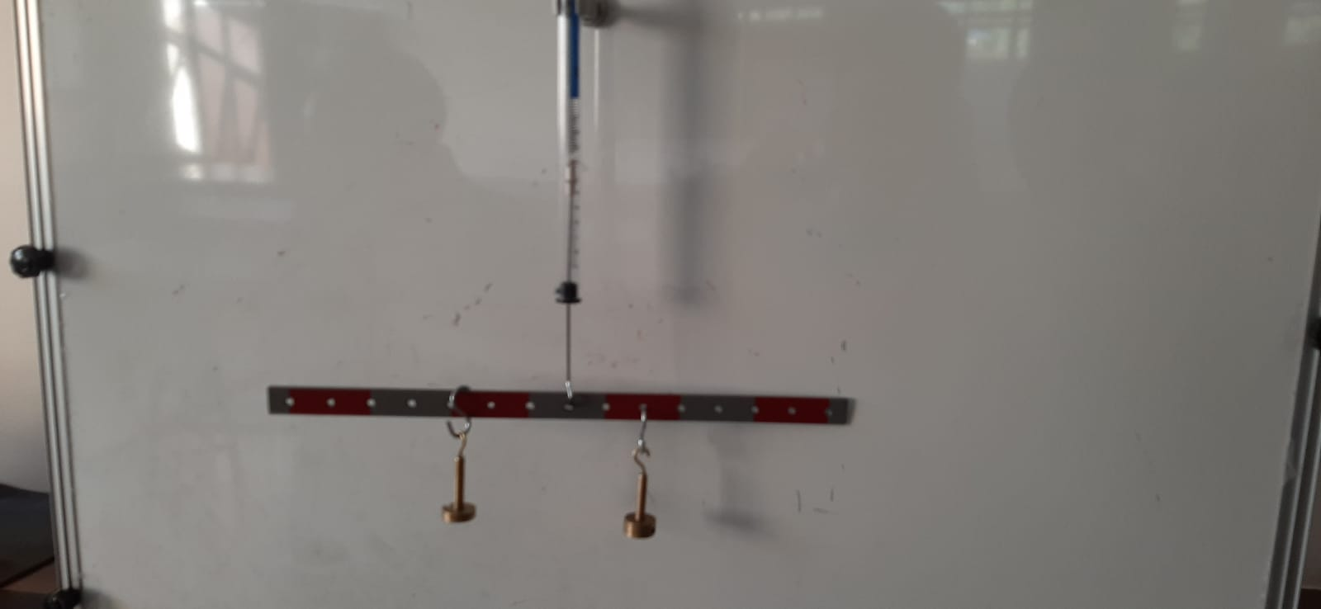
Figure 6
Weight of the rod = 0.5

F2(grams) | F1(grams) | a(cm) | b | L | Total weight
20 | 20 | 5 | 5 | 10 | 0.9
20 | 30 | 7 | 5 | 12 | 1.05
40 | 30 | 6.5 | 5 | 11.5 | 1.25
50 | 40 | 6.2 | 5 | 11.2 | 1.45
50 | 20 | 11.5 | 5 | 16.5 | 1.25
40 | 20 | 9 | 5 | 14 | 1.15
Figure 7

Conclusion
- The resultant of two parallel and concurrent coplanar forces F1 and F2, is a force where the component forces have the same direction and orientation, and the intensity is equal to the sum of the intensities
- The point of application of the resultant divides the segment L in two parts a and b so that the following relation is always verified
F₁ X a = F₂ X b

EXPERIMENT 3

METHODOLOGY

Materials required
- 1 support for dynamometer
- 1 dynamometer 250gr (2.5N)
- 1 rod for levers
- 1 S-shaped hook
- 2 series of 10gr weights with pan
- 1 fixed pulley
- 1 chord

Procedure
- Repeat the previous operations 1-2-3
- Tie on end of the cord to the last hole of the rod
- Fasten the fixed pulley
- Apply a pan to one end of the cord and load it with weights, passing the cord through the groove of the pulley
- Moving the fixed pulley, make the cord perpendicular to the rod
- Find a combination of values F1, F2, b by which the system remains in equilibrium
- Take note of the value of the resultant, considering that the tare is added to the value of F2
- Repeat the test for different combinations of F1, F2, b as in the figure

RESULTS AND FINDINGS

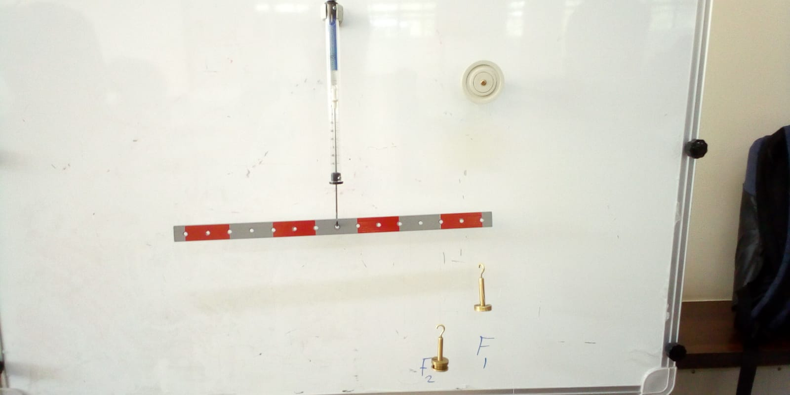
Figure 8

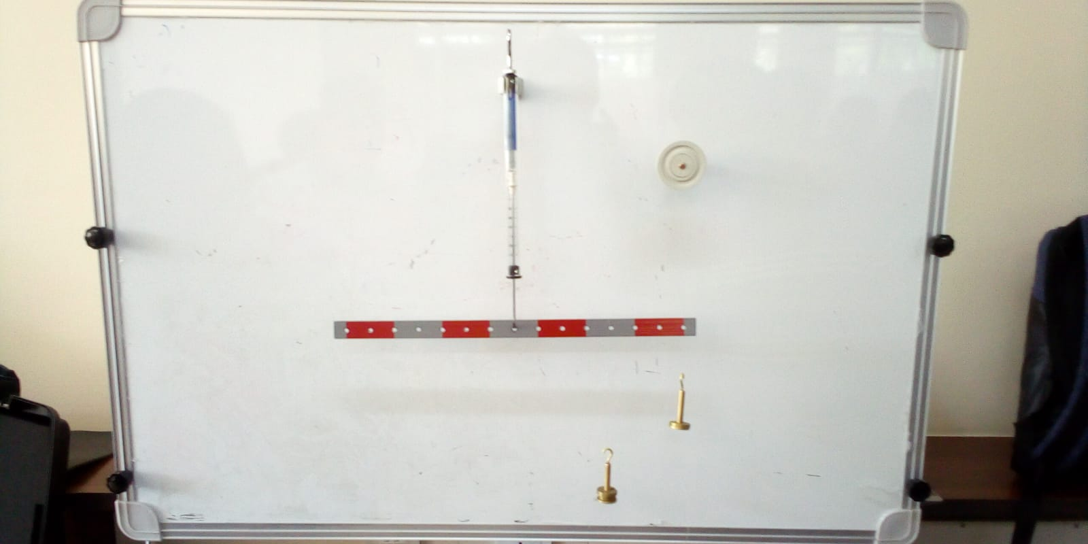
Figure 9

F1 | F2 | a | b | Resultant force
60 | 70 | 17.5 | 15 | 0.60
20 | 30 | 17.5 | 12.5 | 0.50
40 | 70 | 17.5 | 10.5 | 0.75
10 | 20 | 17.5 | 9 | 0.60
10 | 30 | 17.5 | 6 | 0.70
20 | 40 | 17.5 | 9 | 0.70
Figure 10

Conclusions
- The resultant of two discordant parallel forces is a force which has the same direction as the component forces, the orientation being that of the force of higher intensity and intensity being the difference of the intensities of the component forces.
- Its point of application falls outside on the straight line joining the points of application of the two forces and at such a distance that the following relation is verified.

EXPERIMENT 4

METHODOLOGY

Materials required

- 1 support for dynamometer
- 1 dynamometer 250gr (2.5N)
- 2 fixed pulleys
- 2 series of 10gr weights with pan
- 1 cord

Procedure
- Hook the cord to the dynamometer so that it can slide freely
- Fasten the pulleys to the whiteboard
- Apply the pans at the ends of the cord, loading them with some weights
- Acting on the pulleys and on the dynamometer, make the two branches of the cord perpendicular to each other
- Having balanced the system, take note of the force read on the dynamometer
- Repeat the experience, changing the values of F_{x} and F_{y}
- Trace the vector diagram and verify that the intensity of the force F read on the dynamometer is equal to $\sqrt{F_{x}^{2}+F_{y}^{2}}$

RESULTS AND FINDINGS

Mass(g) | F_{x} ² | F_{y}² | F
40 | 20 | 20 | 0.10
60 | 30 | 30 | 0.20
70 | 40 | 30 | 0.30
90 | 50 | 40 | 0.45
110 | 60 | 50 | 0.55
Figure 11
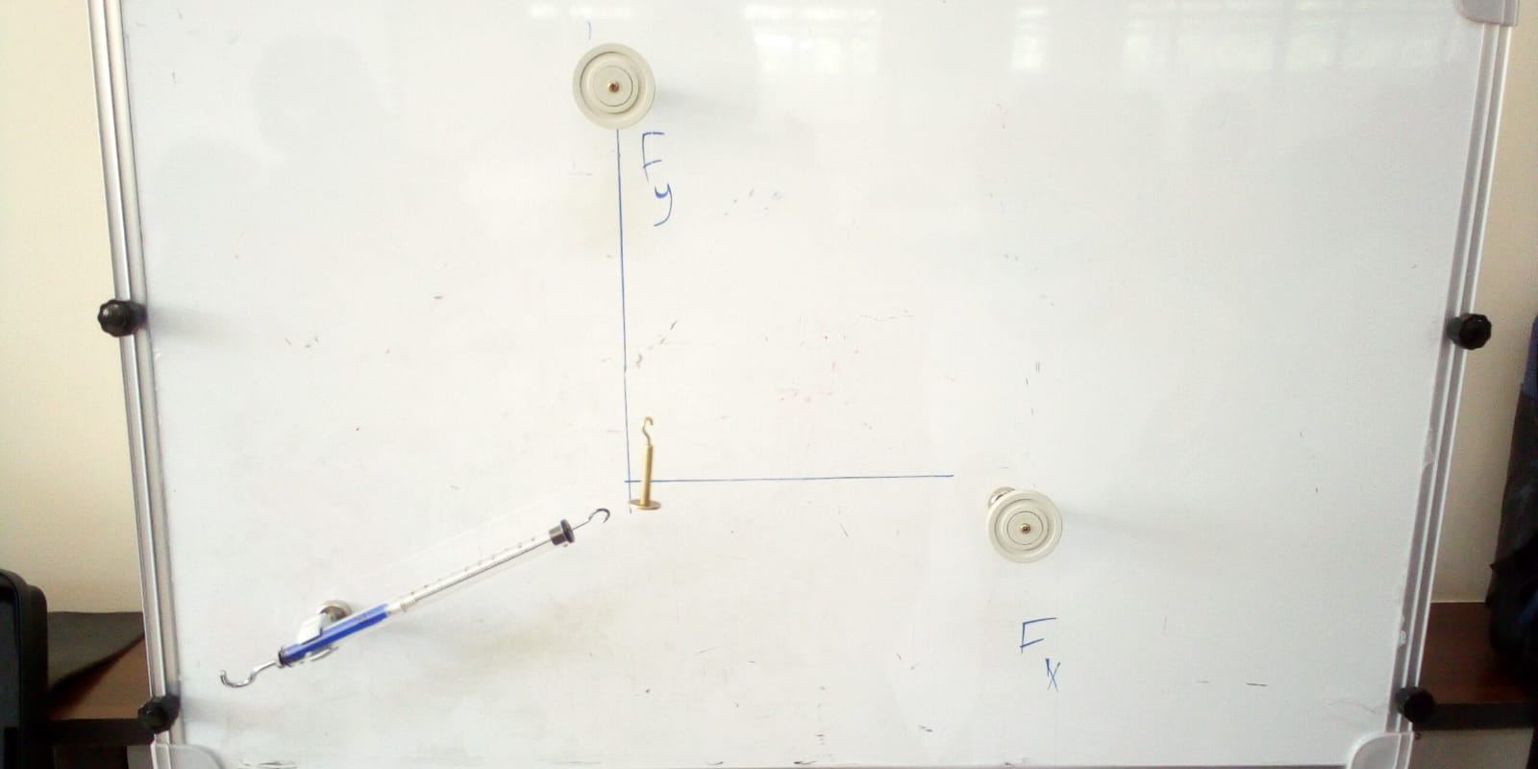
Figure 12

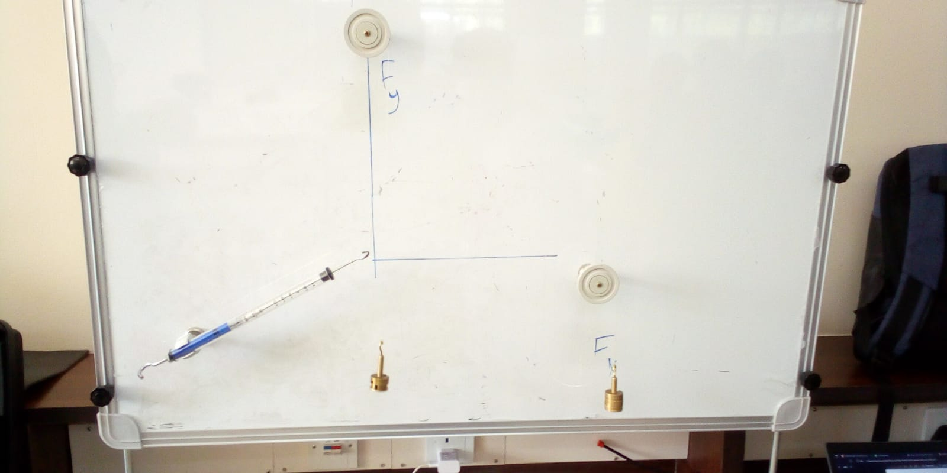
Figure 13

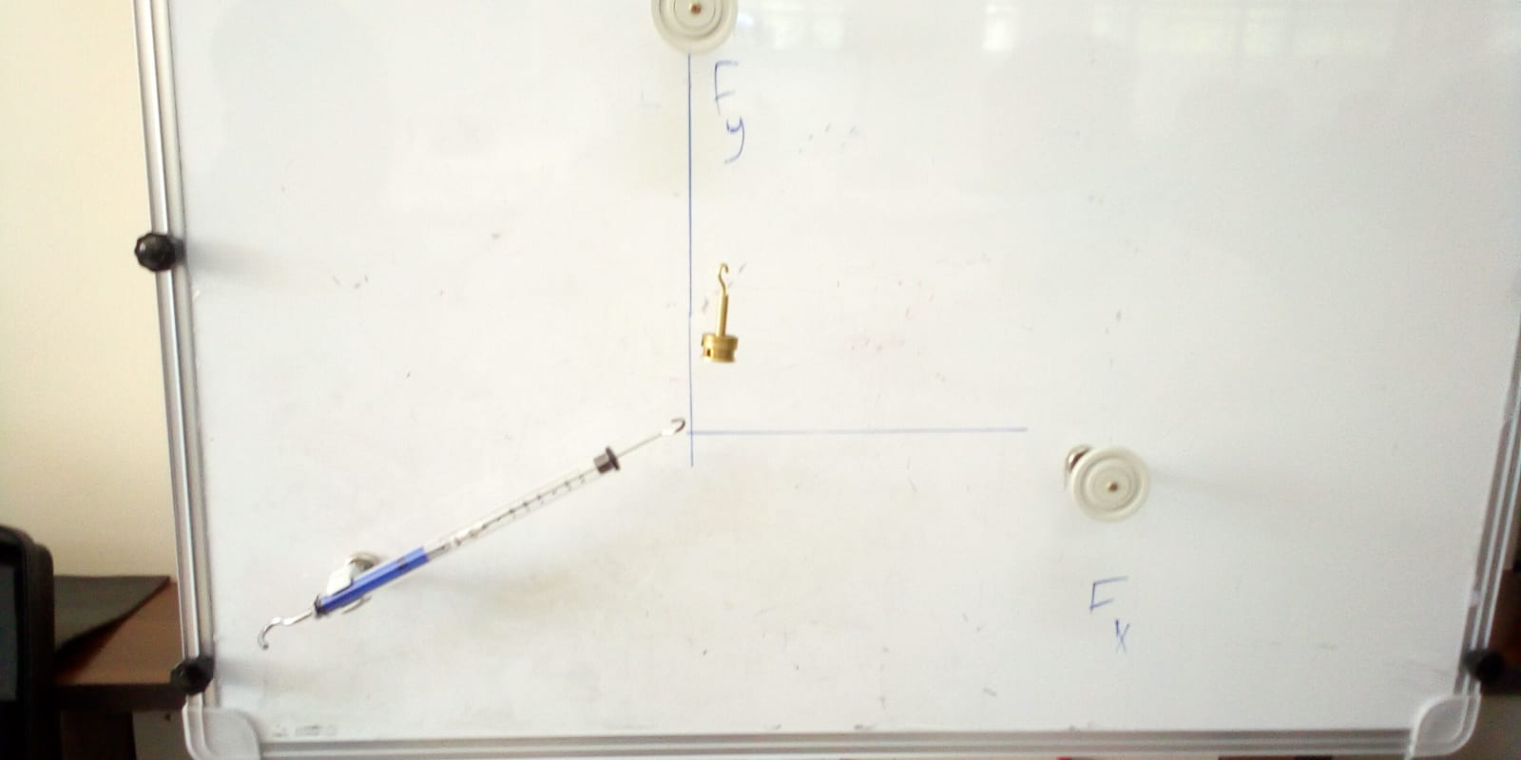
Figure 14

Conclusions
- The forces F_{x} and F_{y} represent the components of the force F along the X and Y axes

EXPERIMENT 5

METHODOLOGY

Materials required
- 1 magnetic support with a hook
- 1 spring with index
- 1 series of 10 gr weights
- 1 ruler

Procedure
- Fasten the magnetic support with the hook to the whiteboard
- Suspend the spring to the hook without any load
- Take note of the height indicated by the arrow (ho) using the ruler
- Load the spring with the 10gr pan and take note of the new value (h1)
- Calculate the elongation ẟh = h1-h0
- Add a further weight of 10gr to the pan. Take note of the new value h2 and of the relative elongation ẟh = h2-h0
- Repeat the operation, adding 10gr weights each time
- Write the results in the table
- Trace a graph, making the applied weight of force the X-axis and the elongations the Y-axis

RESULTS AND FINDINGS

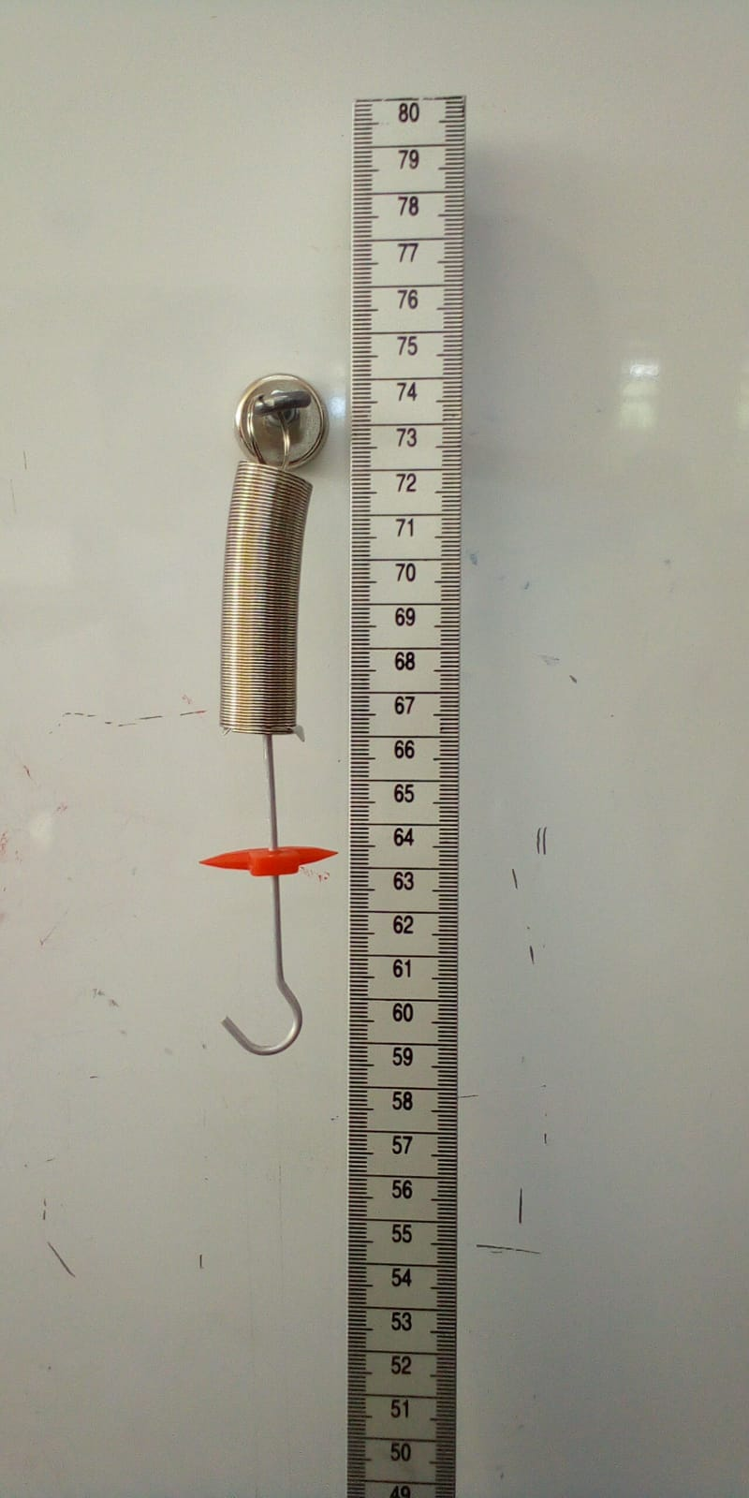
Figure 15
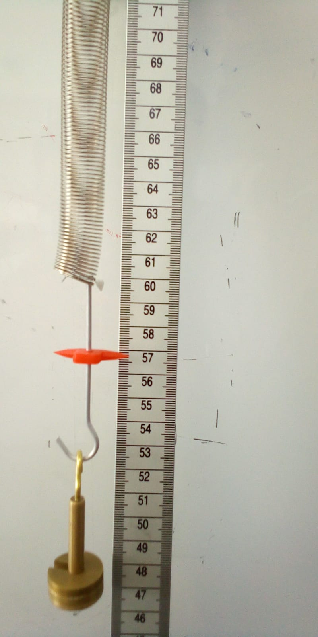
Figure 16
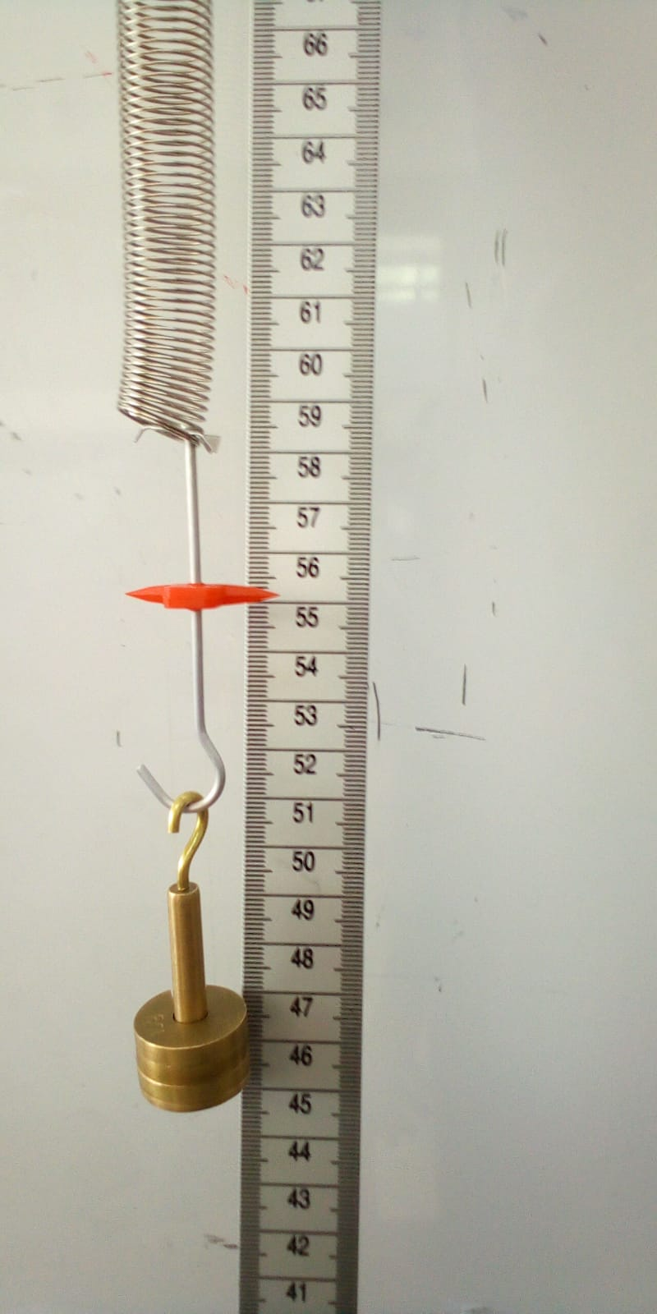
Figure 17
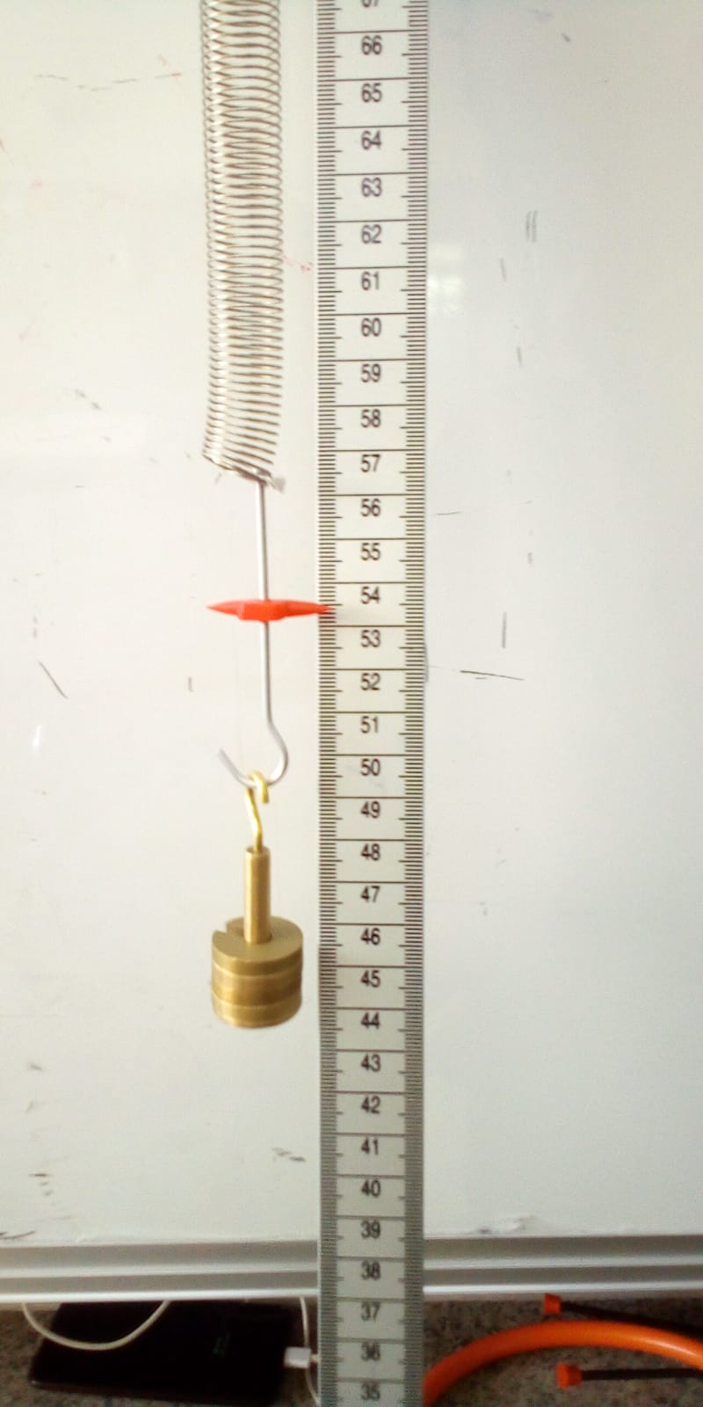
Figure 18
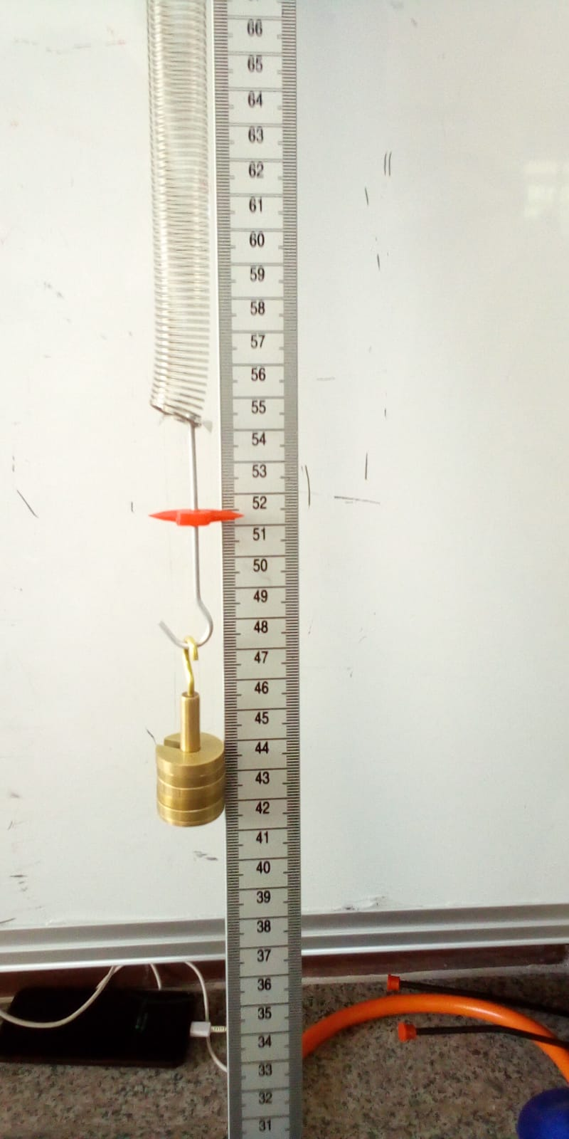
Figure 19
ho = 63.5
F | h1 | Dh | F/dh
 | 62 | 1.5 | 6.67
20 | 59.4 | 4.1 | 4.88
30 | 57.3 | 6.2 | 4.84
40 | 55.3 | 8.2 | 4.88
50 | 53.3 | 10.2 | 4.90
60 | 51.3 | 12.2 | 4.92
Figure 20
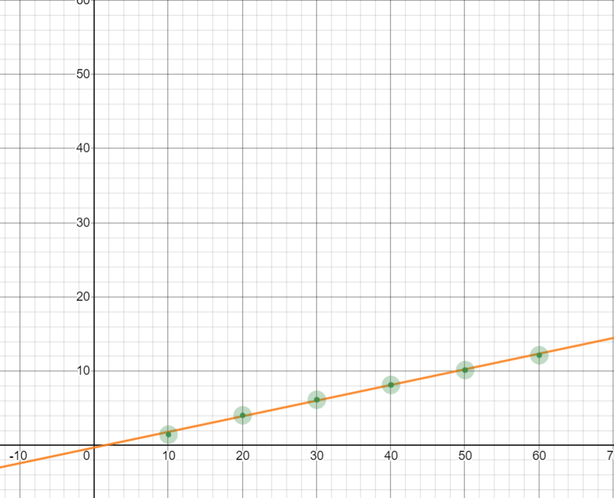
Figure 21

EXPERIMENT 8

METHODOLOGY

Materials required
- 1 support for dynamometer
- 1 dynamometer 250gr (2.5N)
- 1 fixed pulley
- 1 moment disk
- 1 series of 10gr weights with pan

Procedure
- Fix the moment disk
- Fix the dynamometer to the relative support
- Fasten the fixed pulley
- Hook the pans with some weights to the moment disk with the cords in the specific holes
- Hook the dynamometer to the moment disk with a cord, passing it through the groove of the fixed pulley
- Reach equilibrium and read the value of the balancing force in the dynamometer
- Repeat the test changing the application holes of the pans, the load on them and the point of application of the dynamometer

RESULTS AND FINDINGS

F1 | F2 | a | b | Balancing force
60 | 50 | 12.8 | 8.6 | 0.80
60 | 10 | 12.8 | 11.7 | 0.70
30 | 20 | 13.7 | 8.5 | 0.85
30 | 40 | 10.6 | 8.4 | 0.80
Figure 22

Conclusions
-If clockwise moments are assigned a positive sign and anticlockwise negative, check that the following relation is met:
F₃ · b₃ – F₁ · b₁ – F₂ · b₂ = 0

EXPERIMENT 12

METHODOLOGY

Materials required
- Inclined plane on magnetic bases with goniometer
- Magnetic support for dynamometer
- Dynamometer 250gr (2.5N)
- 1 fixed pulley]1 cord
- 1 carriage
- 1 series of 10gr weights

Procedure
- Fix the inclined plane to the magnetic whiteboard
- Fix the support and the dynamometer
- Mount the fixed pulley
- Hook the carriage at one end of the cord
- Hook the other end of the cord to the dynamometer
- Make sure that the cord is parallel to the inclined plane
- Take note of the force indicated on the dynamometer
- Repeat the operation changing the inclination and/or load on the carriage
- Fill out the table

RESULTS AND FINDINGS

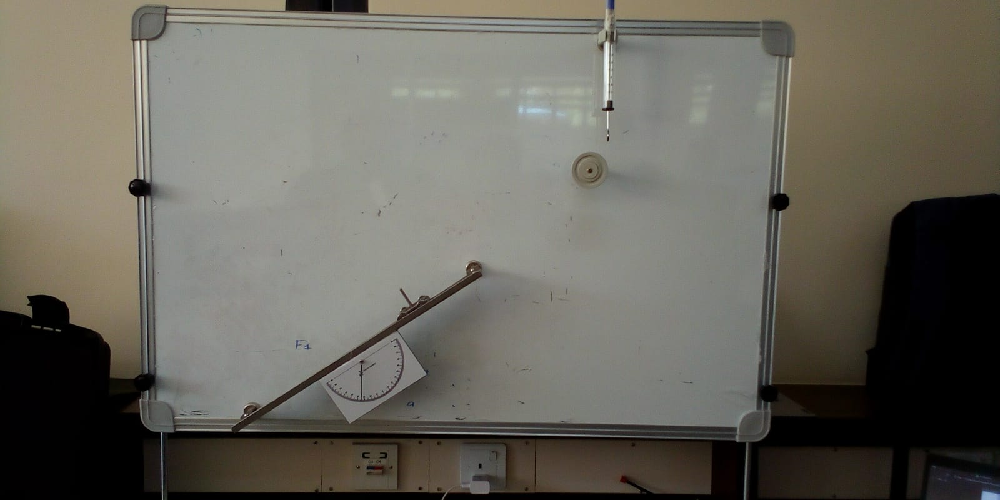
Figure 23

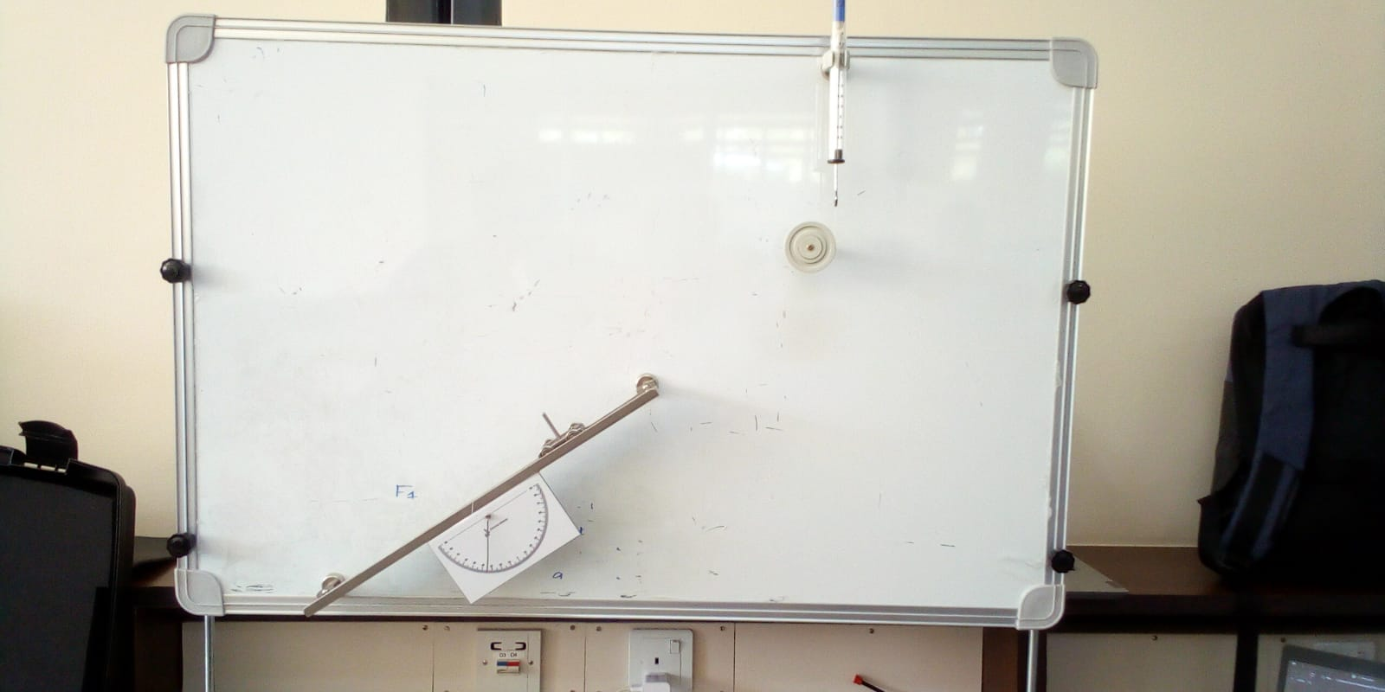
Figure 24

Weight of carriage = 0.40N

Inclination | Weight on carriage | Force on dynamometer
10⁰ | 0.40
 | 0.80 | 0.05
 | 1.10 | 0.10
20⁰ | 0.40 | 0.075
 | 0.70 | 0.15
 | 0.50 | 0.10
 | 0.90 | 0.20
30⁰ | 0.40 | 0.15
 | 0.60 | 0.20
 | 0.70 | 0.25
35⁰ | 0.40 | 0.15
 | 0.50 | 0.20
 | 0.60 | 0.30
 | 0.70 | 0.35
Figure 25

EXPERIMENT 13

METHODOLOGY

Materials required
- 1 wooden block
- 1 series of 10gr weights
- 1 inclined plane with goniometer
- 1 fixed pulley
- 1 cord
- 1 dynamometer

Procedure
- Weigh the wooden block with the dynamometer
- Fix the inclined plane in the horizontal position
- Hook the block to the cord
- Hook the pan to one end of the cord
- Low the pan until the wooden block starts to move
- Repeat the test loading the block with additional weight

RESULTS AND FINDINGS

- 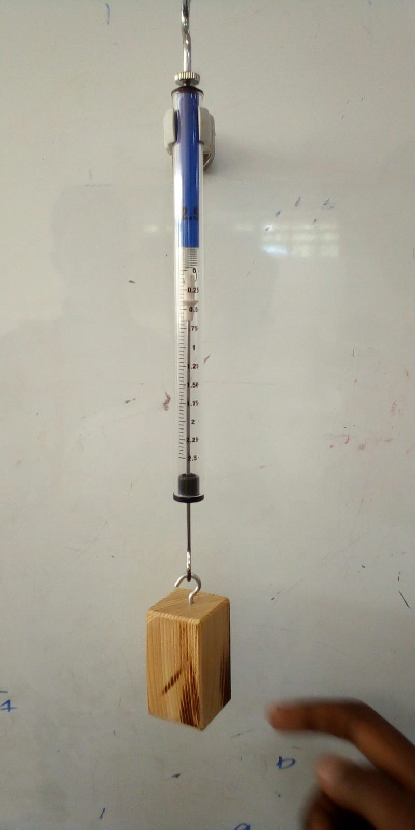
Figure 26
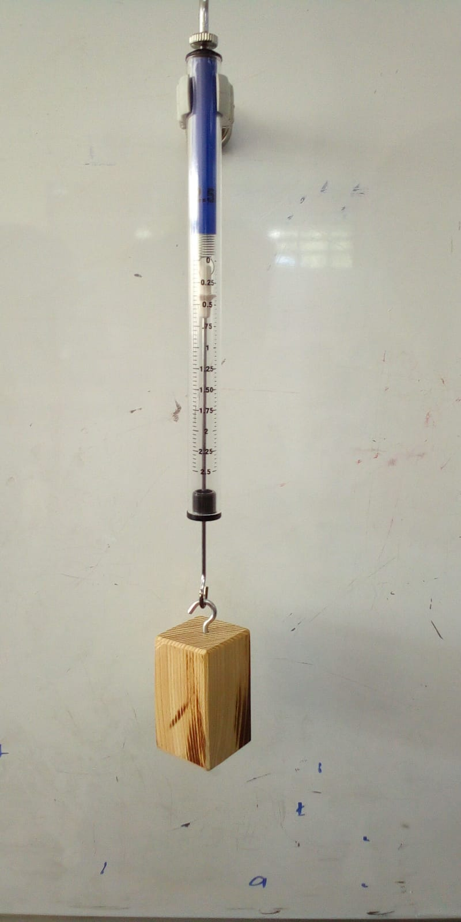
Figure 27
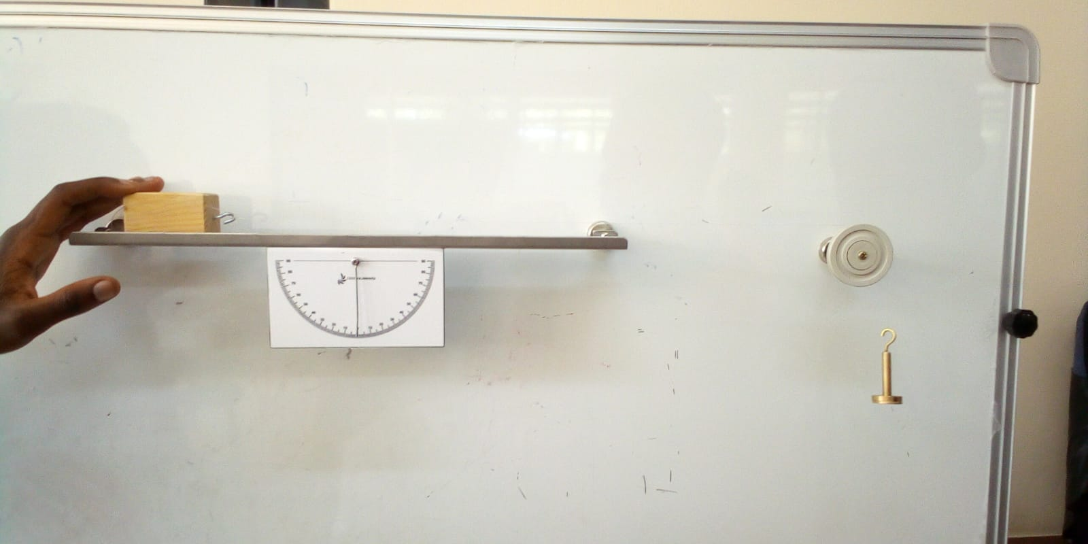
Figure 28

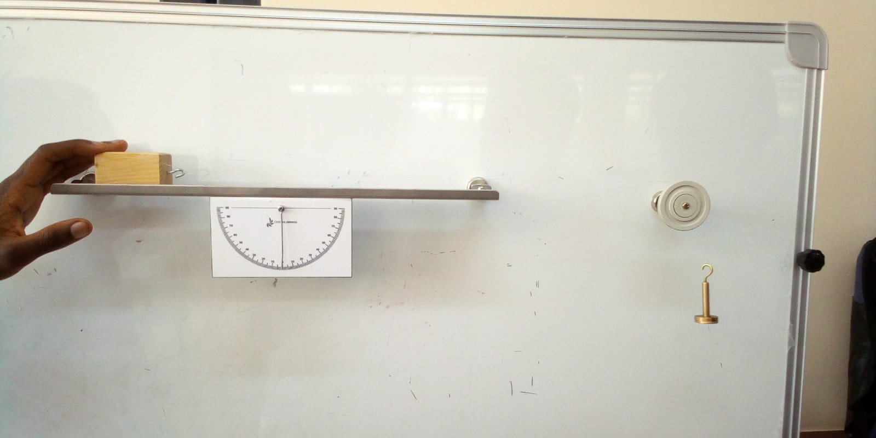
Figure 29
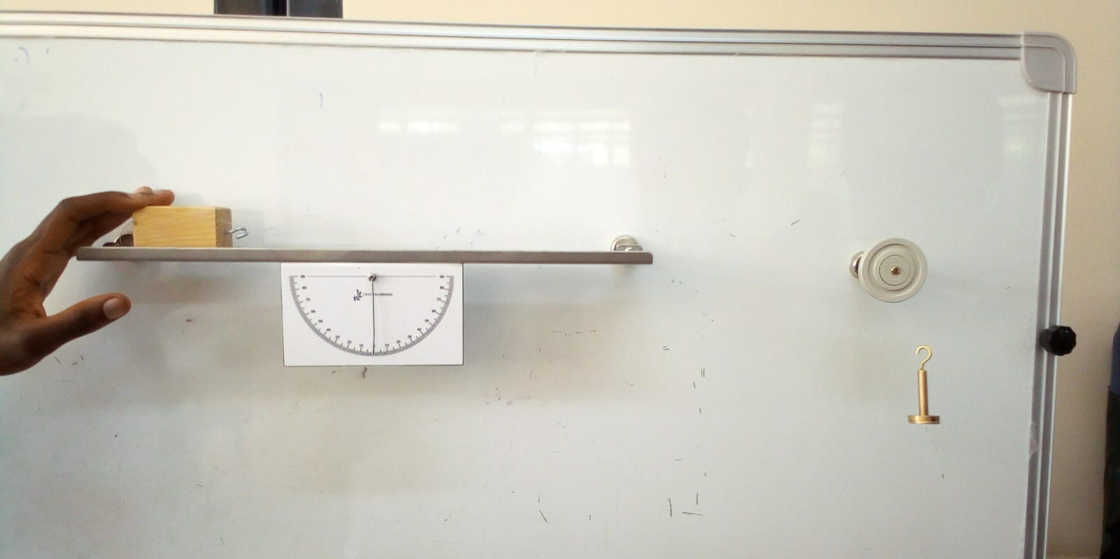
Figure 30

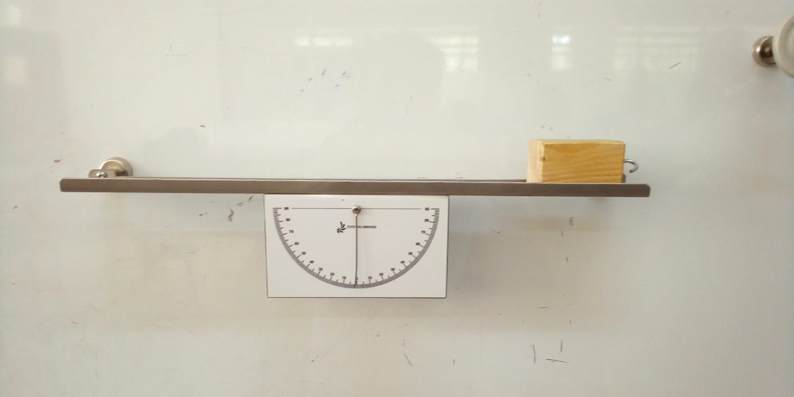
Figure 31
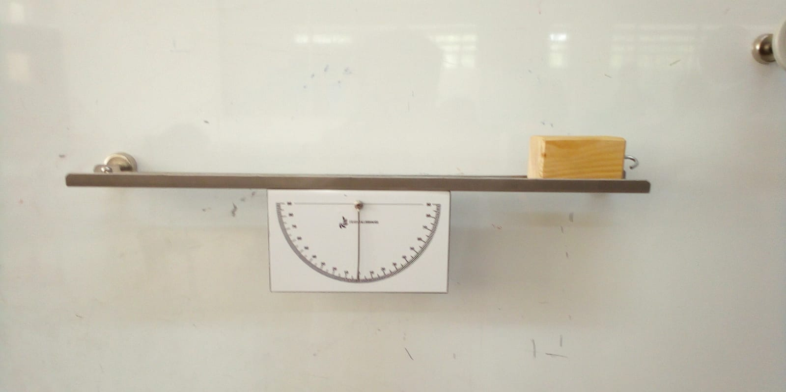
Figure 32

Measurement of the coefficient of kinetic friction

METHODOLOGY
- Place the wooden horizontal on the plane, slowly incline the plane until the block starts to slide (incipient motion). In this position, take note of the angle indicated on the goniometer. As the force of friction is proportional to the pressure force on the plane, in this case we have:
- F_{a} = K_{r} · N
- The graph shows us that
- N = P· cos *
- While in balance
- F_{a} = P· sin *
- The coefficient of friction is therefore expressed as

$$\frac{F{}_{a}}{N}=\frac{P·\sin{*}}{P·\cos{*}}=tg*$$

RESULTS AND FINDINGS

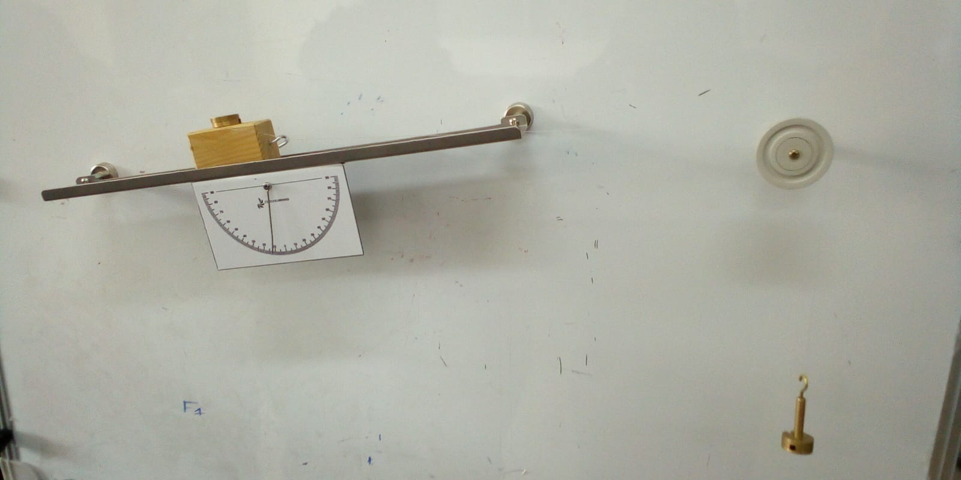
Figure 33

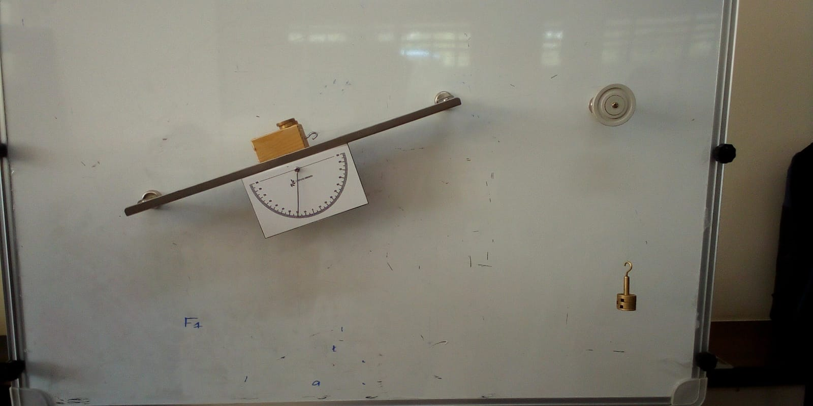
Figure 34

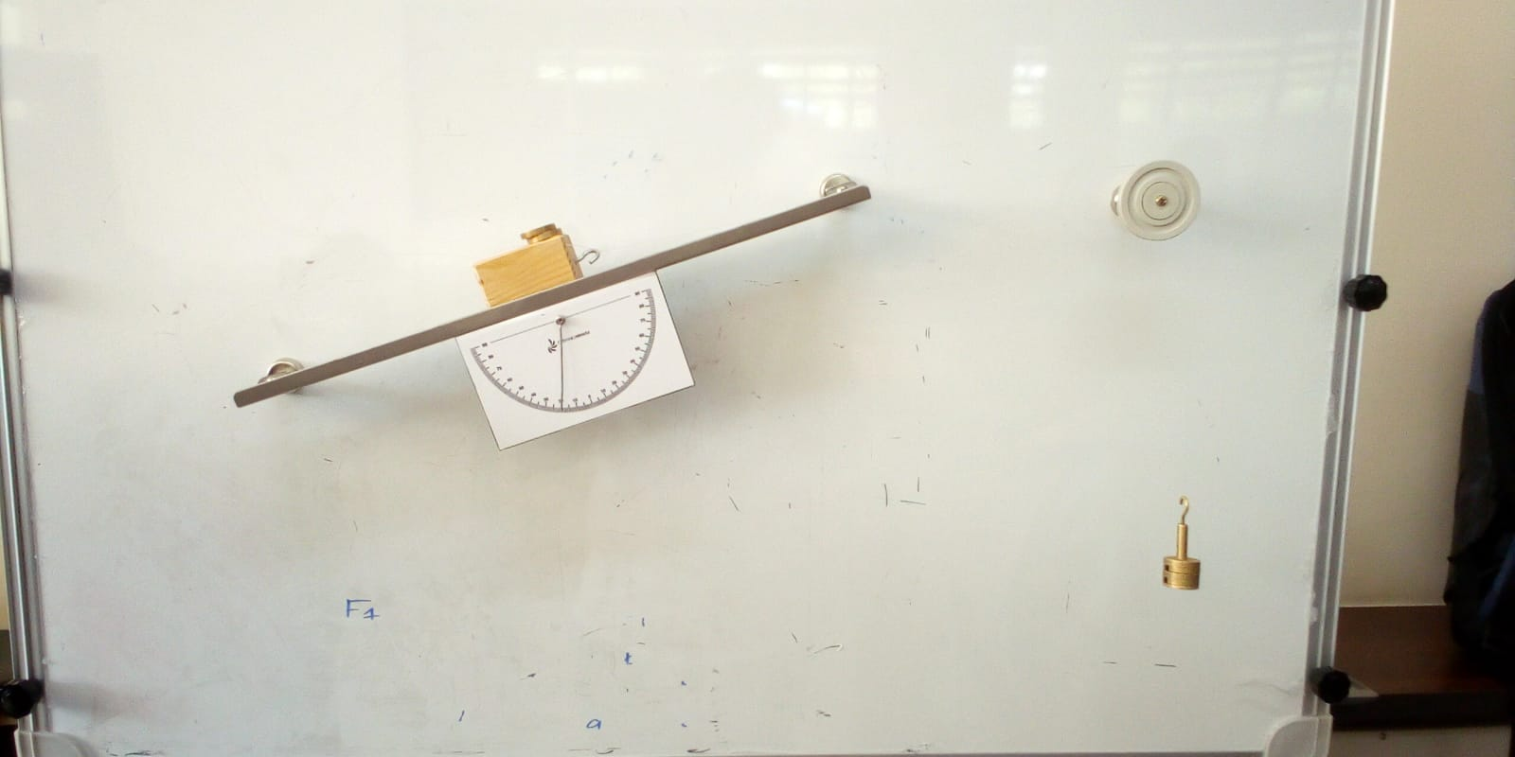
Figure 35

Weight of block = 0.35N

Weight of block | angle | Mass on pan(grams)
0.55N | 10⁰ | 30
0.55N | 20⁰ | 40
Figure 36

PART 2

Experiment 1

METHODOLOGY
- Set up the track using 2 pairs of photogates at distances s₁, s₂ from the lest end and mutual distance s₂-s₁ between them.
- Mount the included shading sheet on the cart (Δx is the shading sheet width)
- Connect the pair of photogates to the data logger at the digital input 1 and 2 and place the cart at the lest end of the track.
- Select the exercise number (1) in the software and enter the distances s₁: first photogate distance from the left end, s₂: second photogate distance from the left end.
- Press the START button on the software and push the cart with your hand in such a way it passes on the metal track in front of the two photogates.
- At the end of the run, the software detects the time t between the shading of the first photogate pair and the shading of the second photogate pair and the shading interval Δt₁ and Δt₂ of the individual photogate pairs.
- The software shows the speed values.

RESULTS AND FINDINGS

T1(ms) | dT | T2(ms) | dT
269.285 | 81.457 | 1301.73 | 119.012
50.713 | 37.892 | 534.136 | 41.131
22.377 | 49.68 | 723.637 | 56.705
Figure 37

Experiment 2

METHODOLOGY
- Incline the track by certain angle.
- Set up the track using 2 pairs of photogates at distance s₁, s₂ from the lest end and mutual distance s₂-s₁ between them.
- Mount the included shading sheet on the cart (Δx is the shading sheet width)
- Connect the pair of photogates to the datalogger (digital inputs 1 and 2) and place the cart at the left end of the track holding it with one hand.
- Press the START button on the software and let the cart go.
- At the end of the run, detect through the software the time t between the shading of the first photogate pair and the shading of the second photogate pair and the shading interval Δt₁ – Δt₂ of the individual photogate pairs.
- The software will calculate the instantaneous acceleration as the shading passes in front of each pair of photogates. Hence it will be possible to verify that a is constant throughout the track and is equal:
A = g · sin *
- Where g is the acceleration of gravity and a is the inclination of the track with respect to the support surface.
- The acceleration at the 2 pairs of photogates is calculated as the ratio between the instantaneous speed and the passing time of the cart in front of the single photogate:

$$v_{1}\frac{Δx}{Δt_{1}}$$
$$v_{2}\frac{Δx}{Δt_{2}}$$
Δx is the width of the shading sheet.
Δt₁ , Δt₂ are the time intervals in which the two photogates are shaded.

RESULTS AND FINDINGS
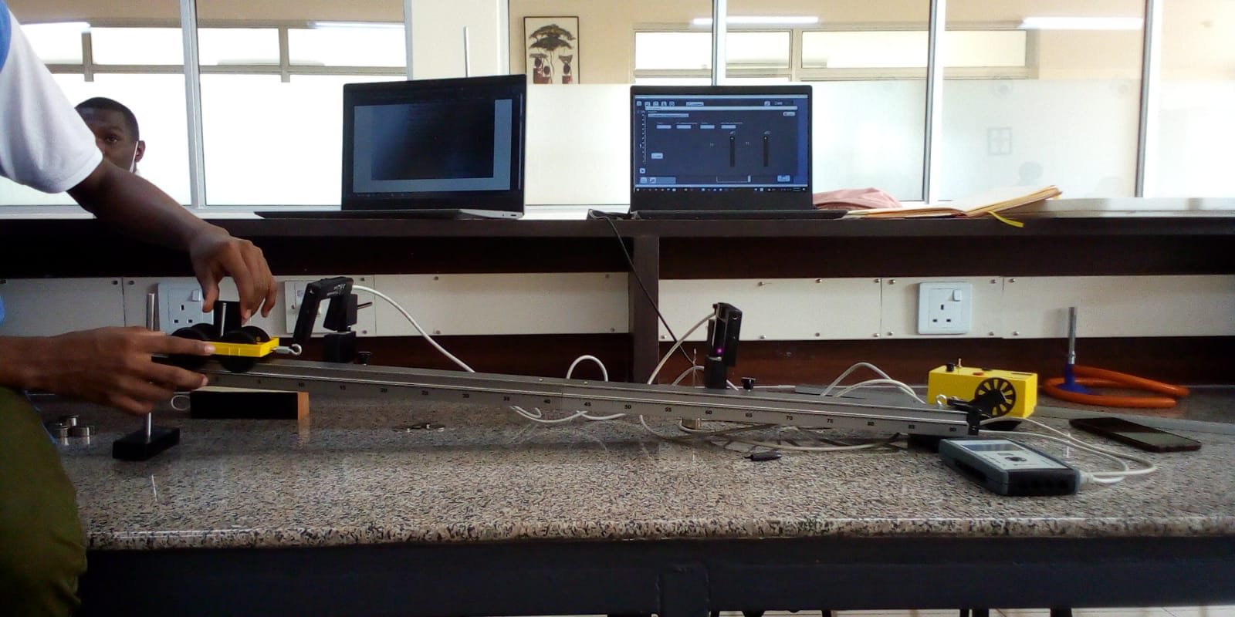
Figure 38
Angle of inclination = 4⁰
Δx = 3.5cm
Distance between S1 and S2 = 51cm
T1(ms) | dt1(ms) | T2(ms) | dt2(ms)
3122.23 | 90.952 | 758.305 | 40.833
1231.43 | 93.826 | 762.539 | 41.509
242.79 | 70.988 | 577.372 | 31.729
Figure 39
V1=0.00385m/s
v2=0.00857m/s

Measurement of the elastic constant of a spring

Objective
- To compare the deformation of a spring with the intensity of the force applied to it, obtaining Hook’s Law, which links the force and the deformation of an elastic body.

METHODOLOGY

Required tools and materials
- Track
- Spiral spring
- Cart
- Masses
- Metric rod

Phases of the experiment
- Hook the spring on one side to the end of the track, on the other side of the cart after weighing it.
- Incline the track by a certain angle.
- The spring under the action of the cart weight tends to stretch
- Determine the extension of the spring by means of a metric rod.
- Change the weight of the cart by adding gradually- increasing mass and immediately determine the elongation.
- Enter the data in the table (masses in the first column and elongations in the third column).
- Determine for each line the force exerted by the mass on the spring, multiplying the value of m by the acceleration of gravity (g = 9.81 m/s²) and by the sine of the track angle of inclination.
- Determine for each line the k between the force F (col. 2) and the stretching ΔL (col. 3)
- Compare the k- values shown in column 4

The same experiment can be carried out for the springs with different elastic constants.

RESULTS AND FINDINGS
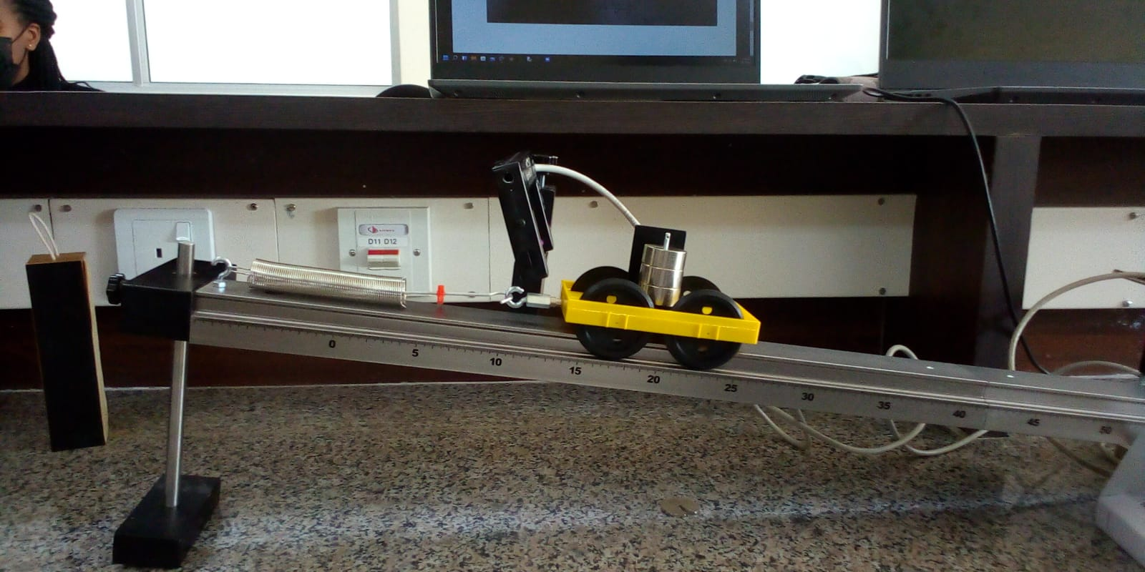
Figure 40

Weight of cart = 0.65N
Mass (Kg) | F = mgsinɵ | ΔL | K(N/m)
0.065 | 0.0698 | 0.72 | 0.0969
0.115 | 0.0787 | 3.2 | 0.0250
0.165 | 0.113 | 4.5 | 0.0251
0.215 | 0.147 | 6.2 | 0.0237
Figure 41

Mass (Kg) | F = mgsinɵ | ΔL | K(N/m)
0.065 | 0.0698 | 1 | 0.0698
0.115 | 0.0787 | 1.8 | 0.0437
0.165 | 0.113 | 2.5 | 0.0452
0215 | 0.147 | 3.4 | 0.0432
Figure 42
The constant for spring 1 is 0.025N/M
The constant for spring 2 is 0.044N/M

Experiment 3

METHODOLOGY

Procedure
- Set up the track using 2 pairs of photogates at distances s₁, s₂ from the left end and mutual distance s₂-s₁ between them.
- Tie a wire to the end of the cart and connect it through a pulley to the weight hanger with weights.
- The shading sheet must be mounted on the cart.
- Connect the photogates to the datalogger (digit input 1 and 2) and hols the cart with your hands.
- START the software and at the same time release the cart: it will move along the track up to the right with uniformly accelerated motion.
- Knowing the distances s_{1,} s₂ from the left end, and knowing the times t₁ and t₂ when passing through the photogates 1 and 2, it is possible to determine the acceleration value:
$$a=\frac{2(s_{1}-s_{2})}{t_{1}^{2}-t_{2}^{2}}$$

RESULTS AND FINDINGS
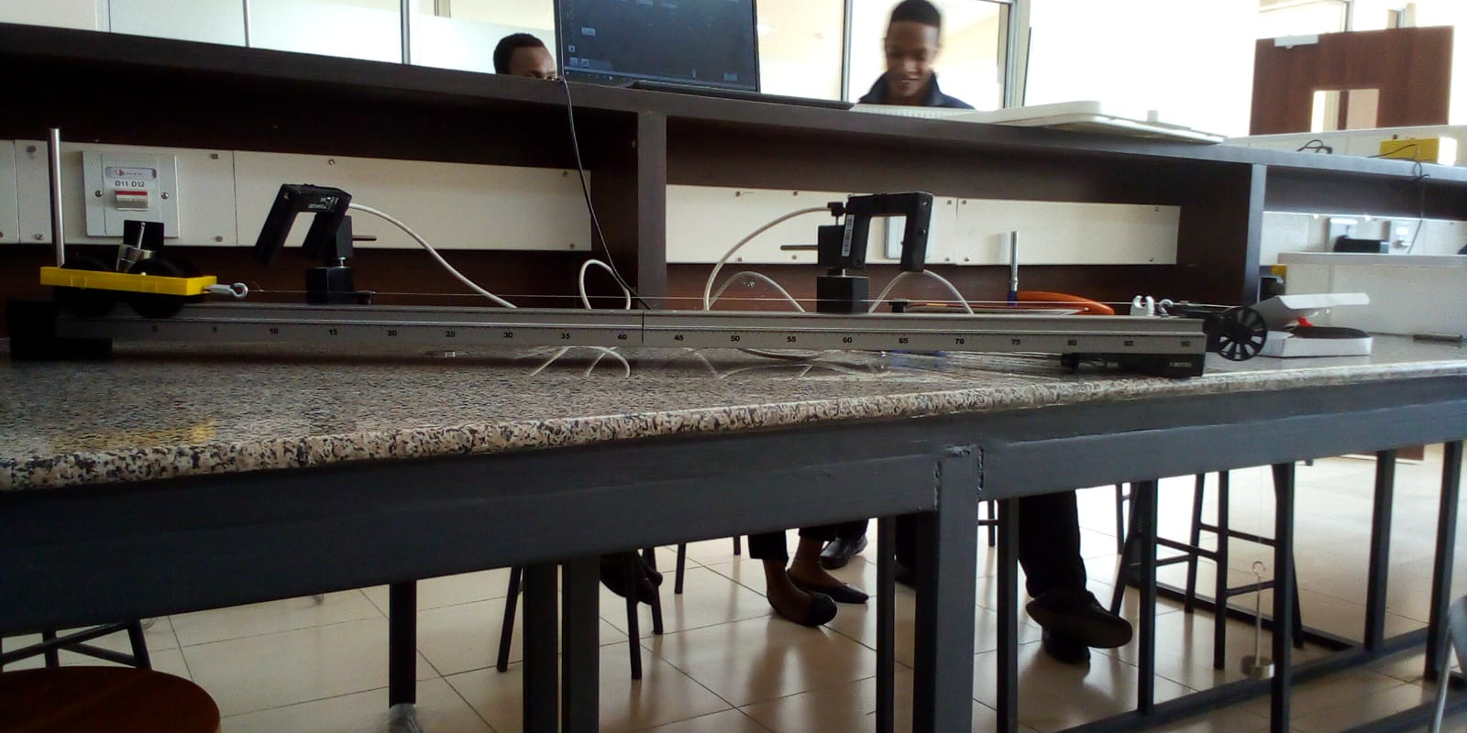
Figure 43

Distance between gates = 51cm
T1(ms) | dT1(ms) | T2(ms) | dT2(ms)
70.66 | 36.916 | 295.576 | 16.036
62.11 | 73.403 | 619.412 | 33.912
Figure 44
A1= 2(20.88)/-224.916
=-0.1857
A2 = 2(39.491)/-557.302
=-0.1417
The cart was decelerating since the rate of acceleration was negative.

Experiment 4

METHODOLOGY

procedure
- Using a scale, determine the mass m₁ of the cart
- Evaluate as in the previous experience the acceleration a₁.
- Add an additional weight of 100gr to the cart: evaluate the new acceleration a₂
- Repeat the previous operation adding another 100gr and evaluating the acceleration a₃
- The mass in motion is equal to the sum of that of the cart plus that of the loaded weight hanger.
- Please enter the data in table for F = cost
Since with the same driving force the product ma remains constant, it can be said that the acceleration is inversely proportional to the mass

RESULTS AND FINDINGS
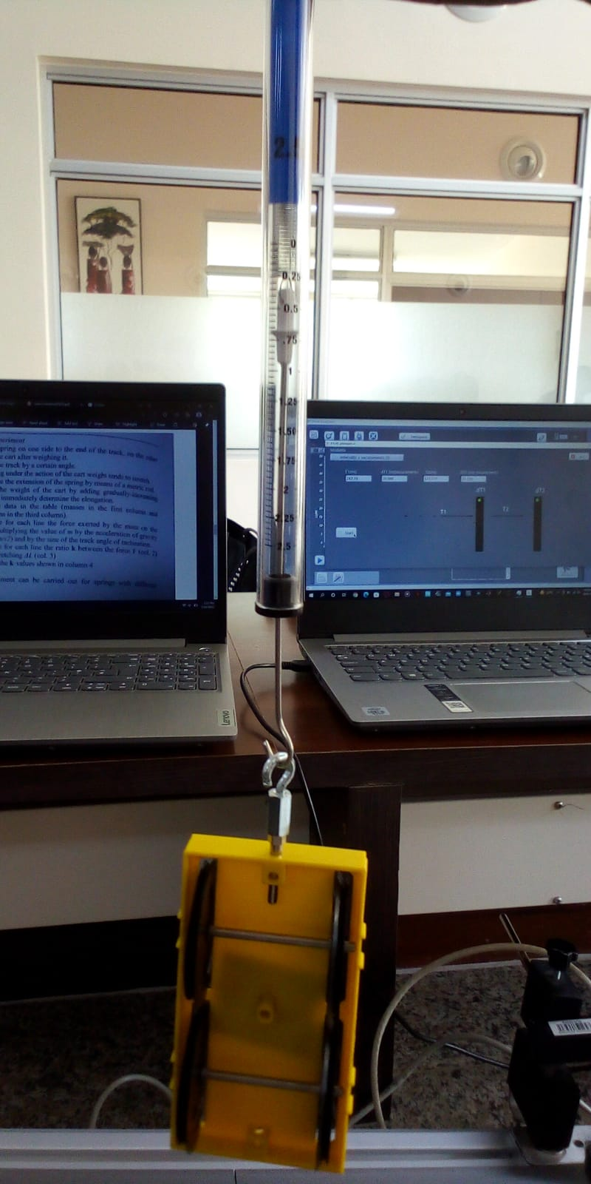
Figure 45
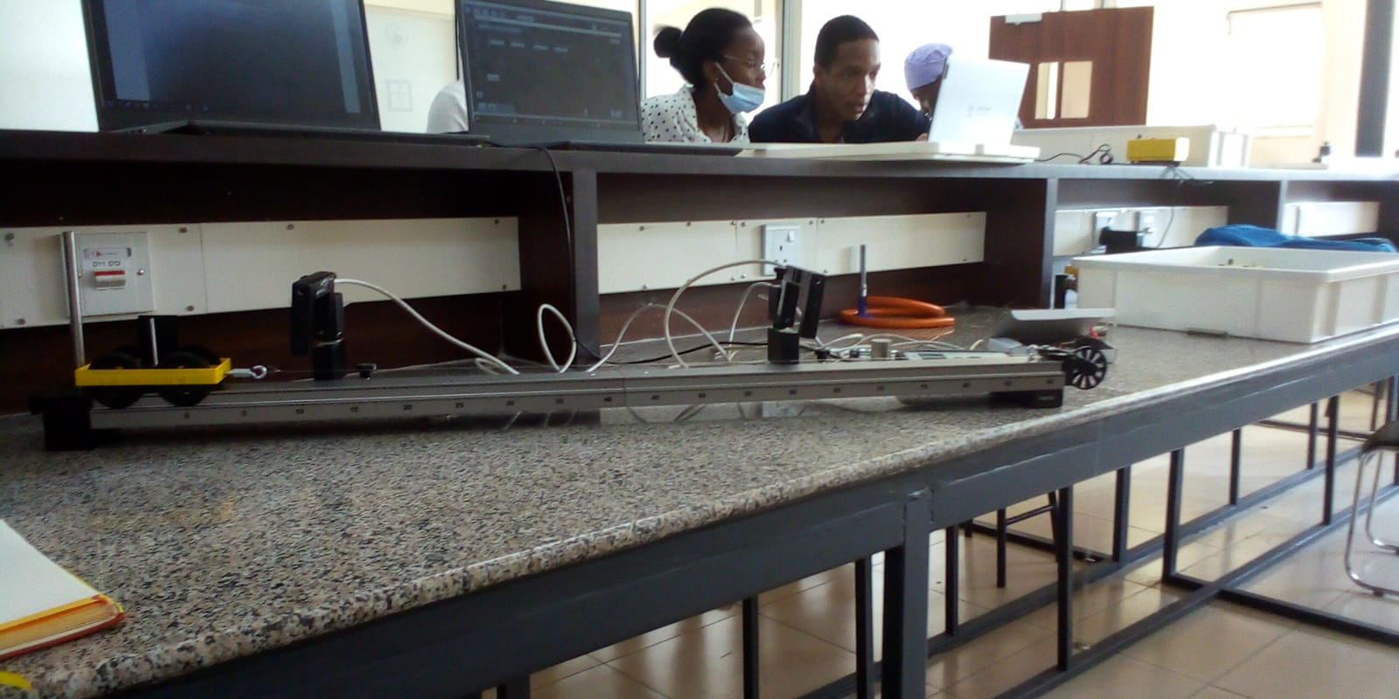
Figure 46

weight of cart= 0.65N
mass | T1 | dT1 | T2 | dT2
0.165 | 571.585 | 162.397 | 1358.26 | 83.624
0.175 | 240.594 | 92.636 | 765.094 | 44.329
0.185 | 56.937 | 72.817 | 592.54 | 34.413
0.215 | 95.346 | 50.419 | 406.881 | 22.874
Figure 47
The more the mass, the faster the acceleration and speed of the cart

REFERENCES
Coplanar Force Resolution. (n.d.). Retrieved March 2, 2022, from http://web.mit.edu/4.441/1_lectures/1_lecture7/1_lecture7.html
Determining the Coefficient of Friction—Succeed in Physical Science. (n.d.). 10.
Friction—Definition, Types of Friction, Applications & Videos. (n.d.). BYJUS. Retrieved March 2, 2022, from https://byjus.com/physics/friction/
What is a Moment? (n.d.). Retrieved March 2, 2022, from https://web.mit.edu/4.441/1_lectures/1_lecture5/1_lecture5.html

